**PAS**

**To:** Dr. Matt Bohm

**From:** PAS

**Project:** Plasma Arc Speaker

**Subject:** Concept Variant 9

**Date:** March 4, 2011

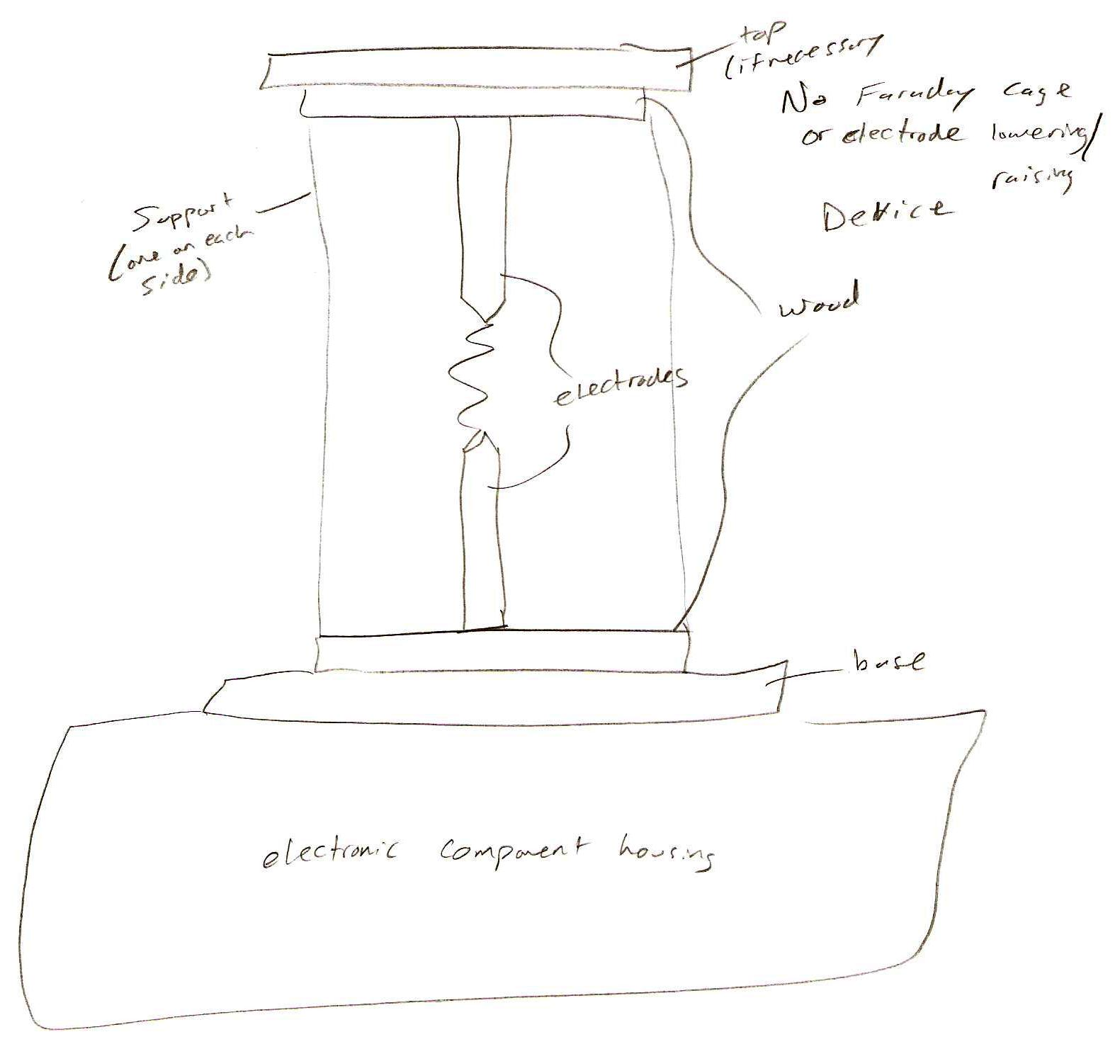

CV 9 consists of an electrical component housing on the bottom.  The electrodes are located vertically above the housing and are insulated with wood or a ceramic material on the top and bottom and are not surrounded by a Faraday cage.  There is no mechanical device to lower or raise any electrodes because the arc will be capable of being initiated at the current distance.